

**L.J. INSTITUTE OF COMPUTER APPLICATION**

**Gujarat Technological University**

**(GTU)**

**PROJECT REPORT ON**

**Shopping Zone System**

**Guided By**:-Prof. Krupa ma’am

**Group No:**ICA_05

**Developed By:**

**1**.Makwana Purvi (205190686059)

**2.**Kadivar Tirth (205170686047)

**3.**Chanchad Vandana (205170686053)

**L.J. INSTITUTE OF COMPUTER APPLICATION**

Near Nagdev Kalyan Mandir,Near Sarkhej cross Roads,

Sarkhej-Gandhinagar Highway Ahemedabad-382210

Ph.No.:0792929634



***CERTIFICATE***

**Enrollment No:** 205190686059

This is to certify that Mr./Mrs. Makwana Purvi studying in Bachelors of Computer Application, Semester V, Roll No.IMS-26 has satisfactorily completed his/her project titled Online Shopping under the supervision of

**Internal Guide Name:** prof.Krupa Shah **signature**

**Date of Submission:20/11/2022**

**Director**

**L.J INSTITUTE OF COMPUTER APPLICATION**

Near Nagdev Kalyan Mandir, Near Safrkhej cross Roads,

Sarkhej-Gandhinagar Highway Ahemedabad-382210

Ph.No.:0792929634



***CERTIFICATE***

**Enrollment No:** 205170686047

This is to certify that Mr./Mrs. Kadivar Tirth studying in Bachelors of Computer Application, Semester V, Roll No.ICA-B-02 has satisfactorily completed his/her project titled Online Shopping under the supervision of

**Internal Guide Name:** prof.Krupa Shah **signature**

**Date of Submission:20/11/2022**

**Director**

**L.J INSTITUTE OF COMPUTER APPLICATION**

Near Nagdev Kalyan Mandir,Near Sarkhej cross Roads,

Sarkhej-Gandhinagar Highway Ahemedabad-382210

Ph.No.:0792929634



***CERTIFICATE***

**Enrollment No:** 205170686053

This is to certify that Mr./Mrs. Chanchad Vandana studying in Bachelors of Computer Application, Semester V, Roll No.ICA-03 has satisfactorily completed his/her project titled Online Shopping under the supervision of

**Internal Guide Name:** prof.Krupa Shah **signature**

**Date of Submission:20/11/2022**

**Director**

**ACKNOWLEDGMENT**

It is over privilege to express our sincerest regards to our faculty and project guide, prof. KRUPA SHARMA, for their valuable inputs, able guidance, encouragement, whole-hearted cooperation and constructive criticism throughout the duration of our project. We deeply express our sincere thanks to our Head of Department prof. MEETU MAM for encouraging and allowing us to present the project on the topic “**Shopping Zone System**”. At our department premises for the partial fulfillment of the requirements leading to the award of Bachelors of Computer Application(BCA) degree. We take this opportunity to thanks all our lecturers who have directly or indirectly helped in our project. Last but not the least we express our thanks to our friends for their cooperation and support.

Makwana Purvi

Kadivar Tirth

Chanchad Vandana

**TABLE OF CONTENTS**

***1. Introduction***

1.1 *Existing System*

1.2 *Needs of the New System*

1.3 *objective of the New System*

1.4 *problem Definition*

1.5 *core components*

1.6 *project profile*

***2. Requirement Determination & analysis***

*2.1Targeted Users*

*2.2 1Requirement Determination*

*2.3 Feasibility Analysis*

***3. System design***

*3.1 Use case diagram*

*3.2 class Diagram*

*3.3 data dictionary*

*3.4User Interface*

*3.5Report Design*

**4. Development**

4.1 Coding Standards

**5. Testing**

5.1 Test Plan & testing Method

**6. Proposed enhancement**

*7.1Proposed enhancement*

**7. conclusion**

*8.1 conclusion*

**8. bibliography**

*9.1bibliography*

1.INTRODUCTION

* In the present time the Shopping stores are looking for the service that are accurate and reliable for providing services to the customers and workers every store is making efforts to computerize their activities for providing better services to the customer. The online shopping store management system is the system used for All inventory in the universal stores .This system enable the manager of the store to record and manage all activities of the Useful Shop

1.1 EXISTING SYSTEM

* There is no existing system.
* The Firm advertises products and takes orders from social media platforms.
* Every work is done manually, from record-keeping to report generation .
* It is difficult for everyone to manage the records of the orders and responses. The Firm can advertise only limited products due to dependency on another platform.

1.2NEED FOR NEW SYSTEM

* Nowadays, in this rapidly digitalizing world it is very important to upgrade our business and take it on our own digitalized platform to expand the business and track and analyze the records more easily and efficiently.
* In the current system it’s hard to manage and keep track of records of the orders as they’re all from different social media platforms
* It’s hard to expand the product range in the current system process as it will be difficult to manage them.
* The business can expand its reach to the customers but due to lack of digitalization, it is limited to an extent.
* In the current process it's difficult to improve the products as per the customer’s needs due to a lack of overall business analysis.

**1.3.OBJECTIVE OF NEW SYSTEM**

* DIGITALIZATION: ○ To take the extent of the business to the next level using digitalization. ○ To improve the availability of services and accessibility by a digital platform.
* EASY INTERACTION: ○ To provide the facility of easy interaction with the customer. ○ To get support from the business easily to the customer.
* MAINTAIN RECORD: ○ To record, maintain and analyze the records of the business. ○ To work on improvement of the business as per the analyzed records.
* BUSINESS EXPANSION ○ To get more customer traffic and advertising to business. ○ To increase sales of the business.

**1.4.PROBLEM DEFINATION**

It’s hard to manage the inventory and orders and the record keeping which is all done manually. The new system will allow the firm to add as many products as it wants due to flexibility of the inventory management and manage the order very easily & rapidly with the help of order management.

Getting onto customers’ feedback, queries, reviews, request, etc is hard due to the unorganized lifecycle of the system’s process. The new system will provide a organized way to get back to customers' with the help of feedback management feedback, queries, reviews, request, etc.

The firm is not completely able to provide its best to the customers due to a lack of platform independence. This system new will give the firm an independent platform so it can be molded and presented in will of the business.

**1.5.CORE COMPONENTS**

***1. User :-***

* *Registration :- User can Register.*
* *Login :- User can Login.*
* *View Product :- User can View Product .*
* *Add to cart :- User can Booking Add to cart .*
* *Order product :- User can order the product*
* *Logout :- User can Logout.*

**2. Admin :-**

* Manage Product :- Admin can Manage the Product .
* Manage inventory : Admin can mange inventory
* Manage order :- Admin can manage order
* Manage User : Admin can manage user
* Manage Feedback : Admin can view and manage the feedback of customer.
* Manage Staff :Admin can manage staff.
* Manage Report : Admin can manage reports.
* MANAGE OFFERS : Admin can manage offers.

**1.6 Project Profile**

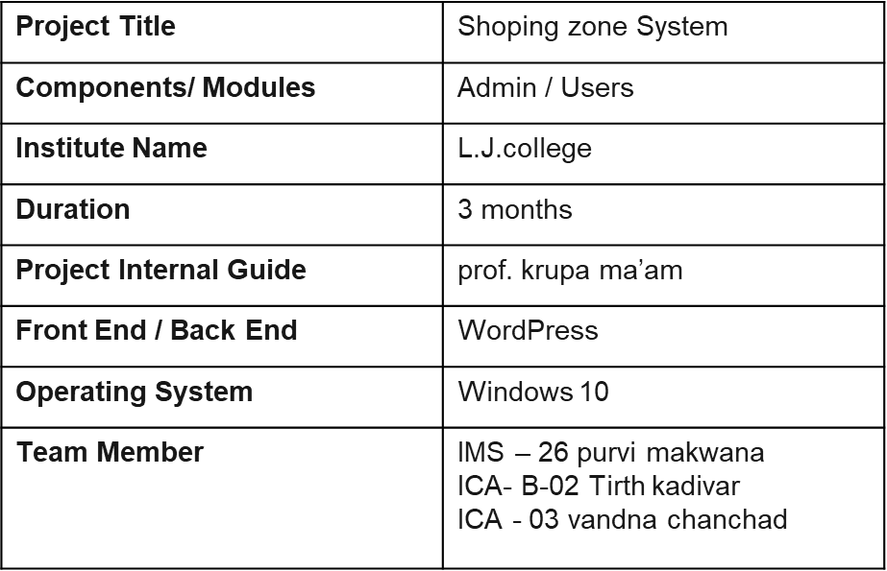

**2. Requirement Determination and Analysis**

**2.1** TARGATED USERS

● ADMIN

● USER WITH MUTUAL INTEREST WHO ARE LEGALLY ALLOWED.

2.2 REQUIREMENT DETERMINATION

➔CLIENT SIDE

◆ HARDWARE REQUIREMENT:

● PROCESSOR: 1.8GHZ(Min.)

● RAM: 2GB(Min)

● INTERNET: 512KBPS(Min)

◆ SOFTWARE REQUIREMENT:

● ENABLED BROWSER

➔SERVER SIDE

◆ HARDWARE REQUIREMENT:

● PROCESSOR: 3GHZ(Min.)

● RAM: 4GB(Min)

● HARD DISK: 2GB(Min)

◆ SOFTWARE REQUIREMENT:

● LINUX OPERATING SYSTEM

3.**System design**

**3.1*Use case Diagram :-***

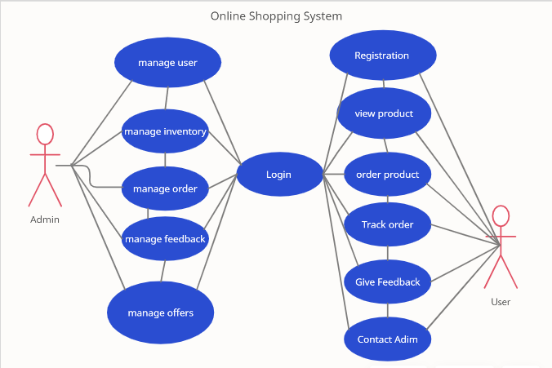

**3.2.*Class Diagram* :-**

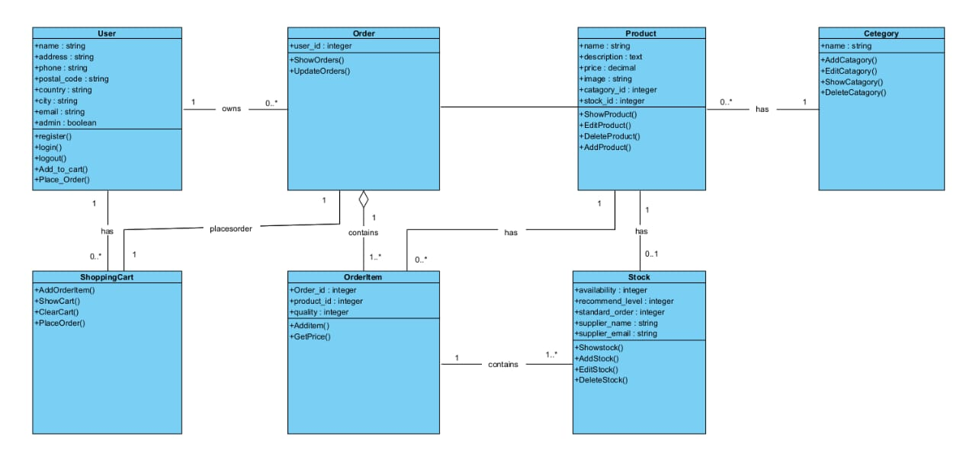

3.3.Data Dictionary :-

1). **Table Name** :- Registration

|  |  |  |  |  |  |
| --- | --- | --- | --- | --- | --- |
| Field | Type | Size | Constraint | Description | Example |
| User_id | Int | 11 | Primary_key | Id of user | 1 |
| F_name | Varchar | 50 | - | First Name of user | Mansi |
| L_name | Varchar | 30 | - | Last Name of user | Patel |
| Email | Varchar | 20 | Unique_key | Email-id of user | abc@gmail.com |
| Username | Varchar | 20 | Unique_key | Username | Abcd |
| Password | Varchar | 15 | - | Password | 1234 |

2). **Table Name**: Login

|  |  |  |  |  |  |
| --- | --- | --- | --- | --- | --- |
| Field | Type | Size | Constraint | Description | Example |
| User Name | Varchar | 20 | - | Name of user | Mansi |
| E-mail | Varchar | 20 | - | User Email id | Mansi@gmail.com |
| Password | varchar | 15 | - | Password | mansi233 |

3). **Table Name**: Order

|  |  |  |  |  |  |
| --- | --- | --- | --- | --- | --- |
| Field | Type | Size | Constraint | Description | Example |
| Booking_id | Int | 15 | Primary_Key | Id of booking | 7996 |
| Booking _id | Varchar | 50 | Foreign_key | Id of booking | 22242 |
| booked_date | Date | - | Date | Date of Order | 22-07-2021 |
| Customer_name | Varchar | 15 | - | Name of Customer | Mansi |

3.5.User Interface :-

* The two interface types found in the online shopping-cart application are as follows: 1. User Interface: Users are able to view the home page of the shopping-cart application, browse the different categories, browse and add any number of items from any categories in the shopping cart, look for information about each product, delete the items in the shopping cart, save the cart for later viewing, check out or continue shopping after adding the item to the cart, and check out the items by completing the required information in the order form.
* 2. Admin Interface: The administrator is able to view the users’ information that was entered during checkout in the database, can update the information, price, shipping costs of the items, add or remove items from the main display.

**4.Development**

4.1Navigation :-

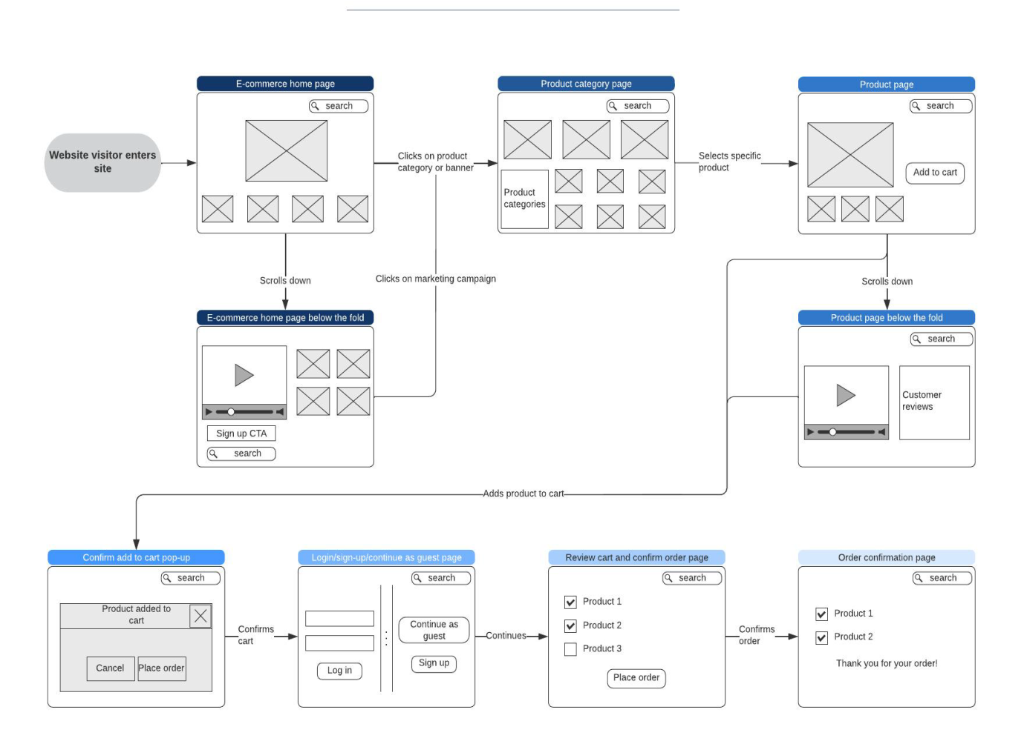

**5.TESTING** :-

* Software testing is a process of running with intent of finding errors in software.
* Software testing assures the quality of software and represents final review of otherphases of software like specification, design, code generation etc.

***5.1.Unit Testing***

Unit testing emphasizes the verification effort on the smallest unit of software

design i.e.; a software component or module. Unit testing is a dynamic method for

verification, where program is actually compiled and executed.

***5.2.Integration Testing***

In integration testing a system consisting of different modules is tested for

problems arising from component interaction. Integration testing should be developed

from the system specification.

**6.Proposed Enhancement:-**

* Advertisement of new product
* Notification of User cart ,sales , discount offer etc.

**7.Conclusion** :-

* In our opinion ,you can go for online fashion hub only if you are searching for low range products and that too with cash on delivery option .For buying product with greater cost ,you must try to visit the standardized shop outside andbargain for the best price . In this case ,if anything goes wrong ,you can directly complain to the person from whom you had purchased the product .

**8.Bibliography:-**

* Website :-
* <https://www.youtube.com/watch?v=Lc2FKHXvKXw&feature=youtu.be>
* <https://www.youtube.com/watch?v=w0YxylKDMKw>

***Screen Shots:-***

Home:

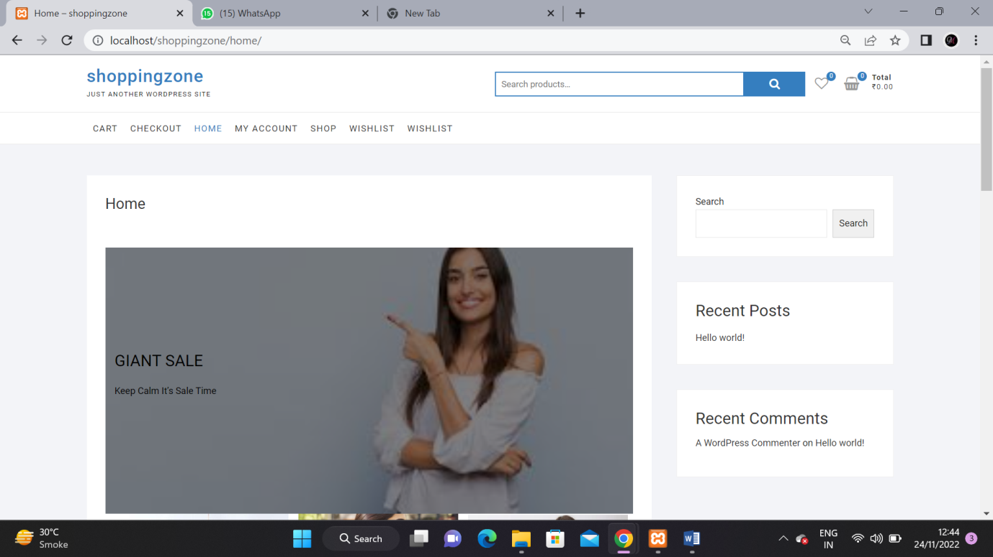

My Account:

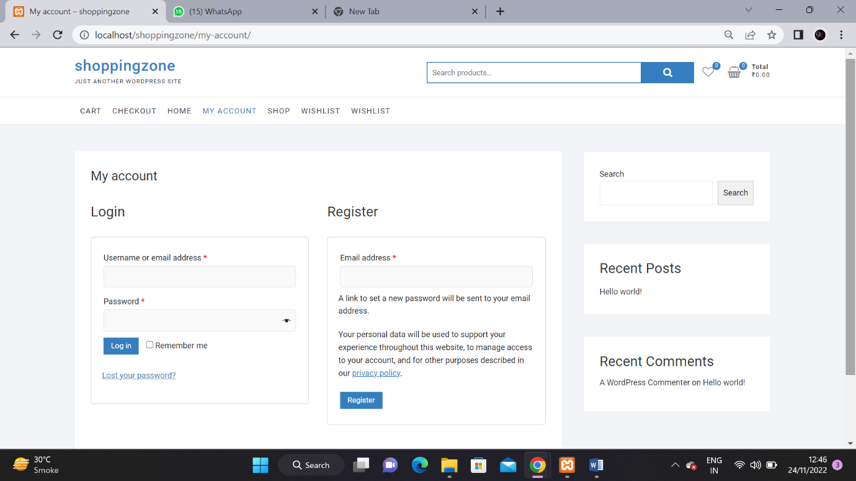

Shop:

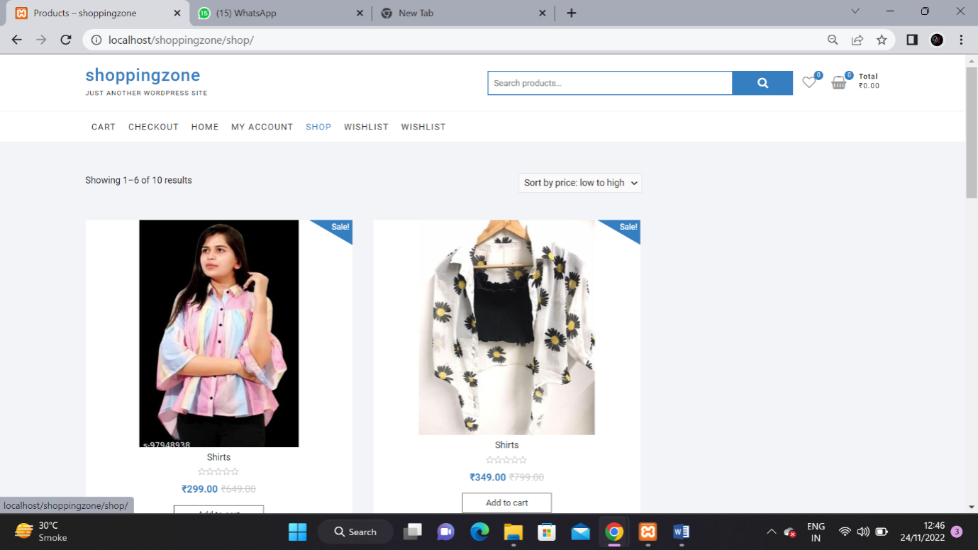

Wishlist:

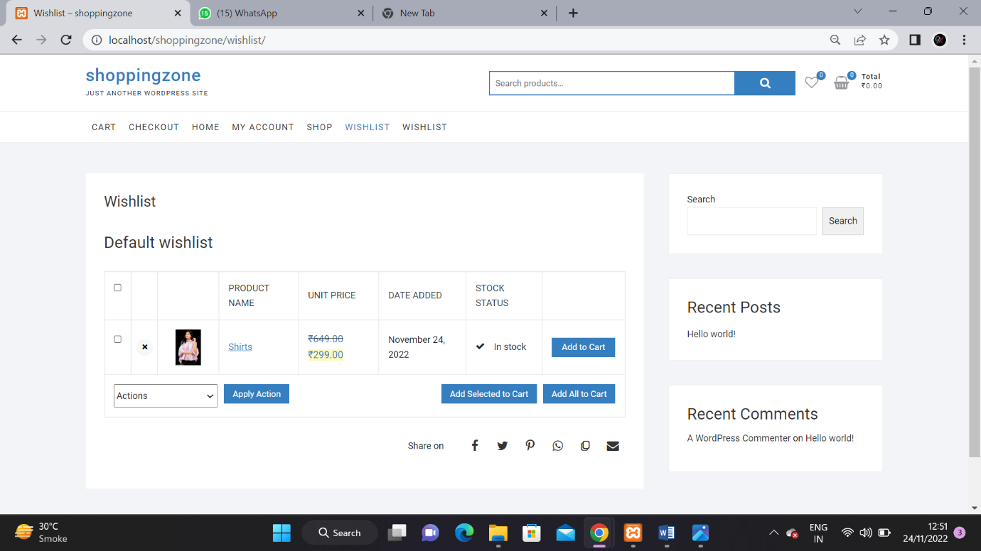

Cart:

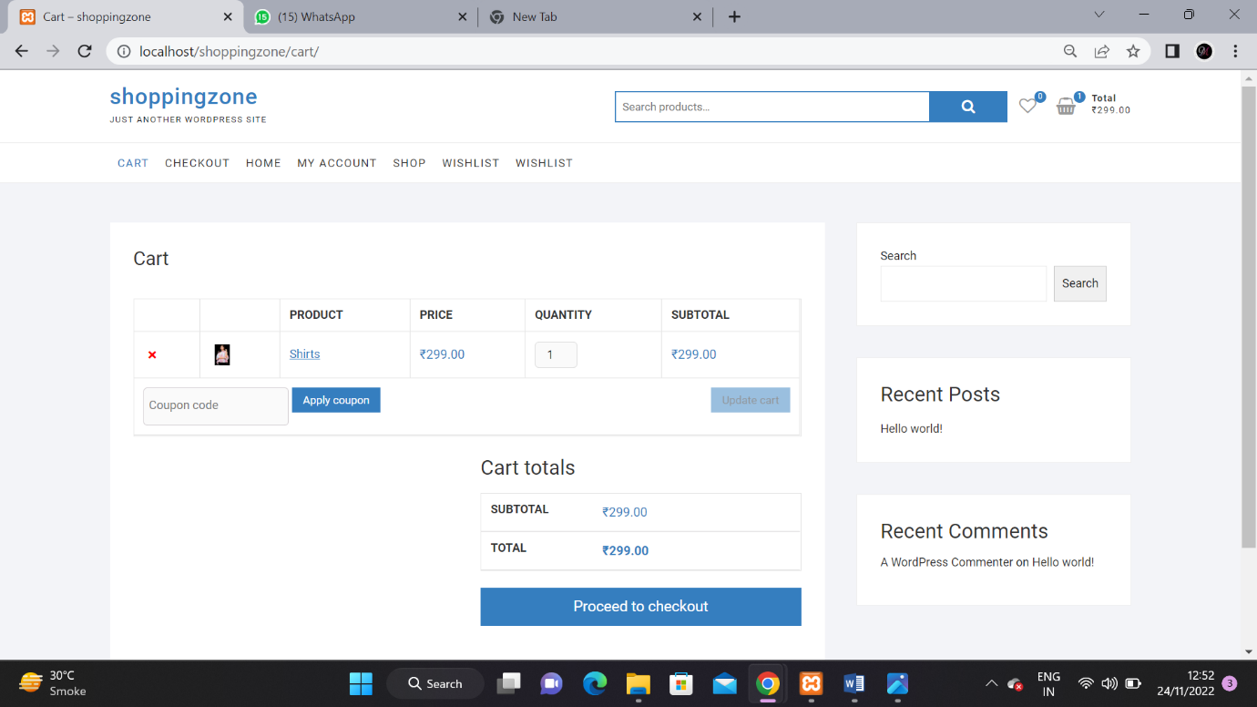

Checkout:

